**Developer’s Guide**

**Installation**

Create Github account and Download Sourcetree (<https://www.sourcetreeapp.com/>) and Git Bash

* 1. In Git Bash, navigate to desired project folder for e.g. “cd *C:/Users/User*”
  2. Run “git clone <https://github.com/wowweijie/rl_forex.git>” in your Git Bash
  3. You now have the project folder in your directory :)

Set Up Anaconda (<https://www.anaconda.com/products/individual>)

* 1. For more info (<https://docs.conda.io/projects/conda/en/latest/user-guide/tasks/manage-environments.html>)
     1. Open Anaconda Prompt
     2. Run conda config --add channels conda-forge and conda config --set channel_priority strict inside the terminal
     3. Navigate to folder containing environment.yml
     4. Run the command conda env create -f environment.yml
     5. Activate the environment with this command conda activate rl_fx
     6. You are now using the shared conda virtual env, nice!
     7. To share environment : conda env export > environment.yml(this will create a new yml file that you should push to github).
     8. To update environment, first change prefix of the shared yml file and run conda env update --prefix ./env --file environment.yml --prune

Install InfluxDB - <https://www.youtube.com/watch?v=s0F5oqOVbw4>

(Use Port 8086 to host InfluxDB)

p

Install Visual Studio Code

* 1. Go to Anaconda Prompt and run command “code” to open visual studios
  2. Settings
     1. Go to workspace and search “Python Path”
     2. Python Conda Path e.g.(D:\User\Anaconda3\condabin\conda)
     3. Python Python Path e.g. (D:\User\Anaconda3\envs\rl_fx\python.exe)
     4. Control + Shift + P and search “Python Interpreter” and select the right Python interpreter

Visual Studio Code Plugins to install

1. Python (Microsoft)
2. Python for VSCode (Thomas Haakon Townsend)
3. Jupyter (Microsoft)
4. Jupyter Notebook Converter (Yigit Ozgumus)

5. Download Tickstory <https://tickstory.com/>

Input currency pair values

* 1. Right click onto currency pair
  2. Select download

6. Integrating Jupyter into VSCode

1. Go to Anaconda Prompt and make sure you are in the (rl_fx) env
2. Run “ jupyter notebook ” command

1. Copy the localhost and put it into vscode Jupyter URI (Click Jupyter when you are on a ipynb file)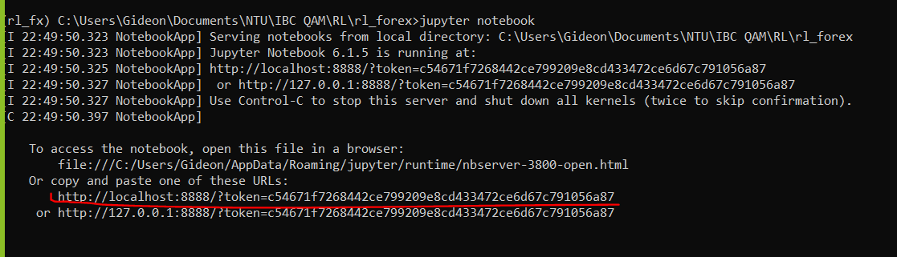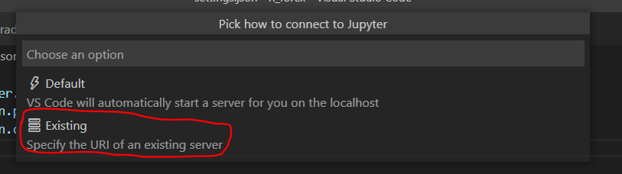

7. How to Integrate IPython in VSCode

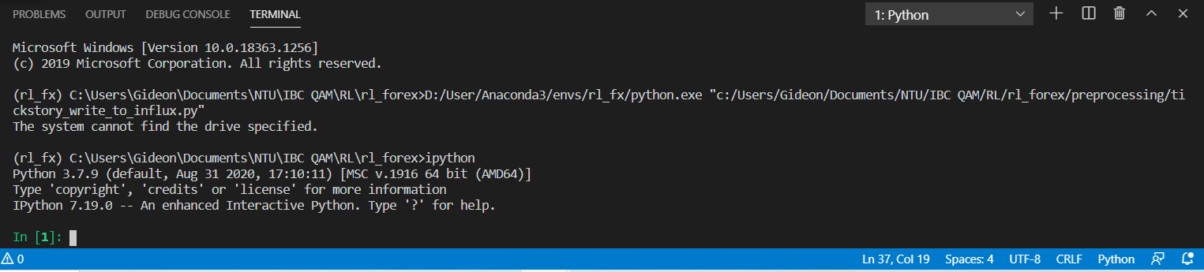

1. Run “ ipython” command in terminal
2. Run “ %run {path to python file from project root}.py ”

8. Writing data into InfluxDB

1. Run the python file in ipython terminal  
   
2. Move csv file into same folder as the python file
3. Run the write_points_from_csv_to_influx function with csv file path name and currency symbol as parameters  
     
   Note: To check current directory  
   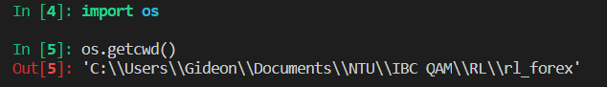
4. Once done, it should return something like this  
   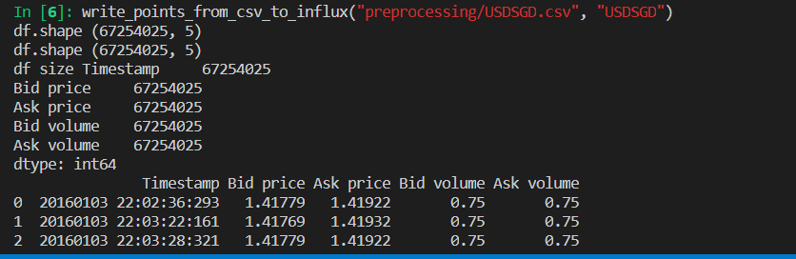
5. Do NOT commit the CSV file into github origin

Integrating Conda with Google Colab

|  |  |  |
| --- | --- | --- |
| 1 | Set up conda in Google Colab | %env PYTHONPATH=  %%bash  MINICONDA_INSTALLER_SCRIPT=Miniconda3-4.5.4-Linux-x86_64.sh  MINICONDA_PREFIX=/usr/local  wget https://repo.continuum.io/miniconda/$MINICONDA_INSTALLER_SCRIPT  chmod +x $MINICONDA_INSTALLER_SCRIPT  ./$MINICONDA_INSTALLER_SCRIPT -b -f -p $MINICONDA_PREFIX  %%bash  conda install --channel defaults conda python=3.6 --yes  conda update --channel defaults --all --yes |
| 2 | Check Python version | !python --version |
| 3 | Create environment “myenv” | !conda create --name myenv  !conda init bash |
| 4 | Append conda to sys.path | import sys  _ = (sys.path  .append("/usr/local/lib/python3.6/site-packages")) |
| 5 | Remove Colab packages from sys.path | import sys  sys.path.remove('/usr/local/lib/python3.6/dist-packages') |
| 6 | Export environment to yml file | !conda env export > environment.yml    File will appear here |
| 7 | Import environment to yml file | !conda env create -f drive/MyDrive/rl_fx_environment.yml |
| 8 | Install packages | !source activate rl_fx  && !conda install <package> --yes |

**Workflow**

1. Each member one feature branch
2. Copy rl_environment.yml into project folder